Assignment 3
Bsce22045
Bsce22009
Bsce22048

Question 1
Class diagram

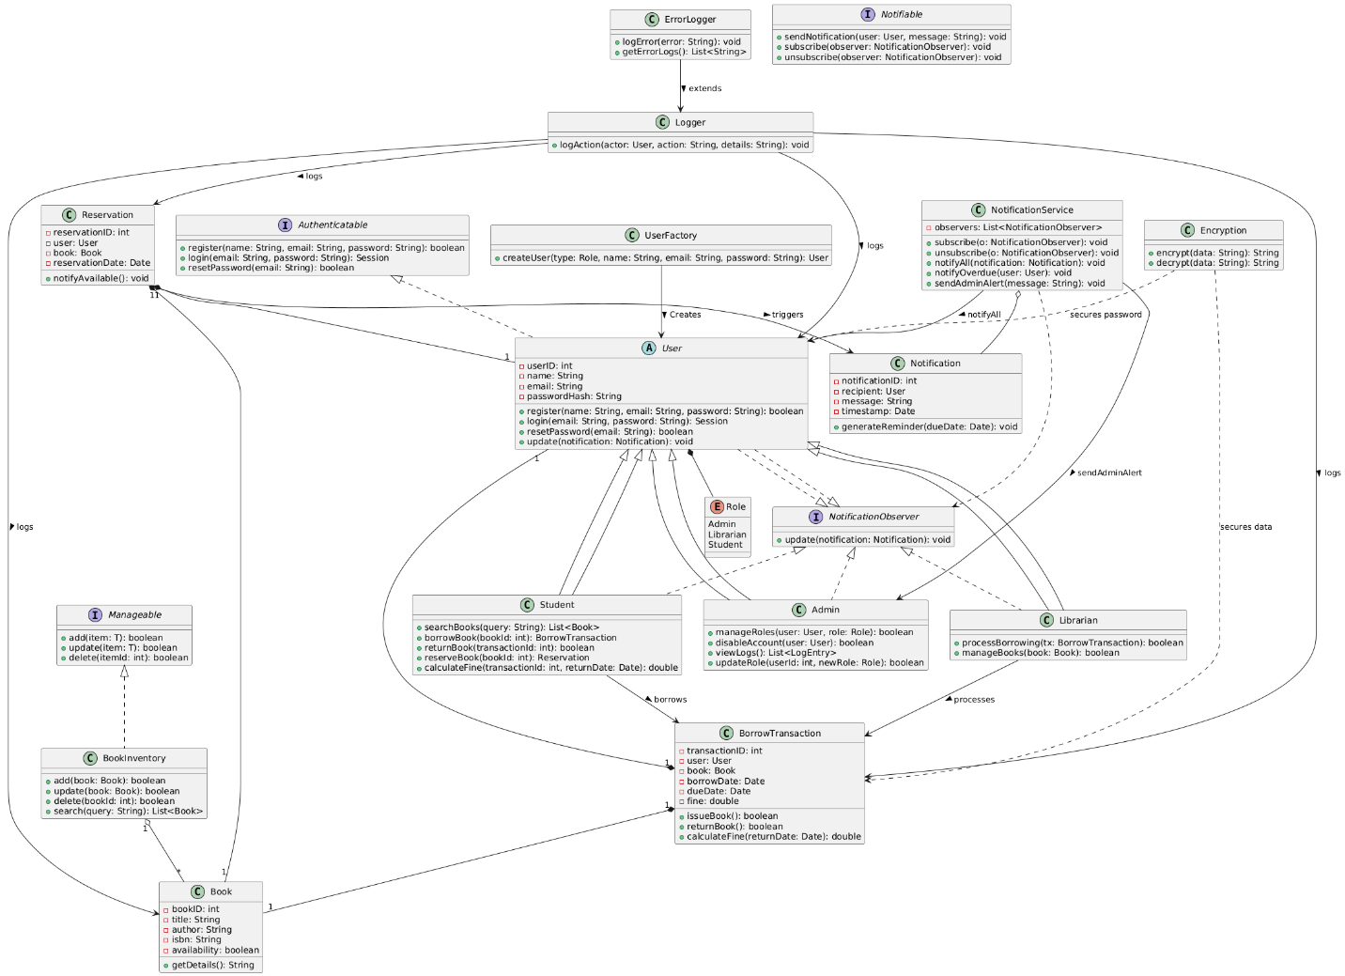

The class diagram represents the structural model of the Secure Library Management System, addressing all use cases defined in the project scope. Below is a detailed explanation of the components and their roles within the system:

1. Interfaces
a. Authenticatable
- Ensures that any User can:
  - Register with the system.
  - Login using their credentials.
  - Reset their password when necessary.
b. Manageable
- Provides a generic interface for managing entities, such as adding, updating, and deleting objects. This is implemented by the BookInventory class.
c. Notifiable
- Manages notifications for users, enabling subscription, unsubscription, and sending of notifications.
d. NotificationObserver
- Defines an observer interface that allows users to receive notifications from the system, implementing the Observer Design Pattern.

2. Abstract & Concrete User Roles
a. User (Abstract)
- Base class for all user types (Admin, Librarian, and Student).
- Implements Authenticatable and NotificationObserver interfaces.
- Handles common functionalities like registration, login, password reset, and receiving notifications.
b. Admin
- Extends User to perform administrative tasks:
  - Assign roles for other users.
  - Update roles explicitly via the new updateRole(userId, newRole) method.
  - Disable user accounts if needed.
  - View system logs for auditing purposes.
c. Librarian
- Extends User to manage library operations:
  - Process book borrowing transactions.
  - Manage the book inventory (add, edit, delete, search records).
d. Student
- Extends User for library interactions:
  - Search for books.
  - Borrow and return books.
  - Reserve books and calculate overdue fines if applicable.

3. Domain Classes
a. Book
- Represents a library book with attributes like title, author, ISBN, and availability status.
- Provides functionality to retrieve book details.
b. BookInventory
- Manages the collection of books in the library.
- Implements Manageable to add, update (edit), delete, and search books.
c. BorrowTransaction
- Tracks transactions for borrowing books, including borrow date, due date, and fines.
- Methods:
  - Issue a book to a user.
  - Return a book and calculate overdue fines based on return date.
d. Reservation
- Allows users to reserve books and receive notifications when they become available.
e. Notification
- Represents notifications sent to users, such as reminders for due dates or overdue fines.

4. Utility Classes
a. Logger
- Logs user actions, such as book borrow and return events, reservation actions, and system notifications.
b. ErrorLogger
- Extends Logger to track and record system errors, supporting robust error handling.
c. Encryption
- Ensures secure communication by encrypting sensitive data, such as passwords and transaction details.

5. Design Patterns
a. Factory Pattern (UserFactory)
- Simplifies user creation based on roles (Admin, Librarian, or Student).
- Ensures consistency in user object instantiation.
b. Observer Pattern (NotificationService and NotificationObserver)
- Manages a list of observers (users) who are notified of system events like overdue fines, book availability, and administrative alerts.

6. Relationships
a. User and Role
- User is associated with a Role (Admin, Librarian, or Student).
b. BookInventory and Book
- BookInventory manages multiple Book instances.
c. BorrowTransaction
- Each transaction links one User and one Book.
d. Reservation and Notification
- A Reservation can trigger a Notification when a reserved book becomes available.
e. NotificationService
- Acts as the central hub for sending notifications to users and admins.
f. Logger and System Components
- Logs actions performed on various components, including users, books, transactions, and reservations.
g. Encryption
- Provides security by encrypting data related to users and transactions.

Key Features Supported
- User Management: Includes registration, login, password reset, role assignment, role updating, and account disabling.
- Library Operations: Supports borrowing, returning, reserving books, adding/editing/deleting/searching book records, and overdue fine calculations.
- Notifications: Implements reminders for due dates and overdue fines using the Observer Pattern.
- Administrative Control: Enables admins to monitor system activity, update user roles dynamically, and perform high-level management tasks.
- Security and Error Handling: Ensures secure data handling via encryption and robust error logging.

Question 2
Below is the dynamic model of the system which covers all the use cases.

1. Sequence Diagram: User Registration
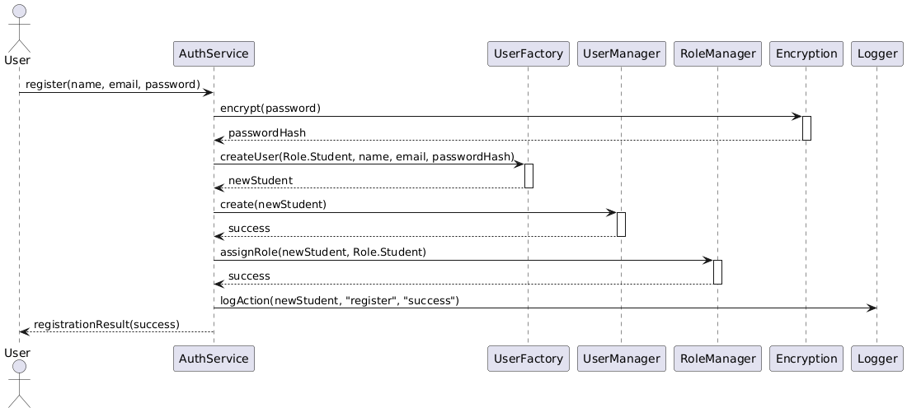

Actors & Components: User → AuthService → Encryption → UserFactory → UserManager → RoleManager → Logger
Explanation:
When a new user signs up, the User (UI) invokes AuthService.register(). The password is first encrypted by Encryption. AuthService then delegates user creation to UserFactory, which returns a concrete Student (or other) instance. UserManager persists the new user, and RoleManager assigns the default “Student” role. Finally, Logger records the successful registration. This flow demonstrates the Factory (user creation) and AuthService coordinating Authenticatable operations.

2. Sequence Diagram: User Login
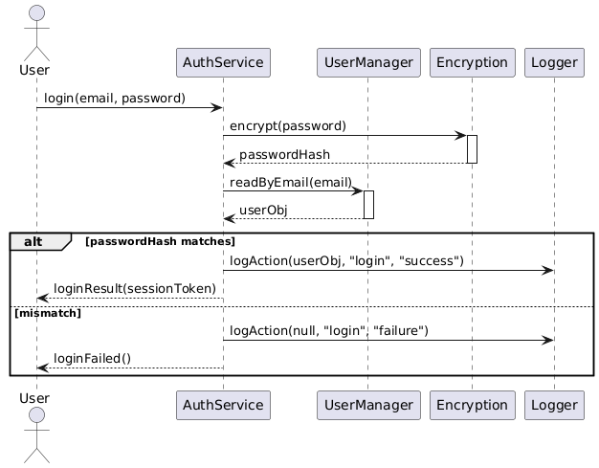

Actors & Components: User → AuthService → Encryption → UserManager → Logger
Explanation:
For login, the User provides credentials to AuthService.login(). The password is encrypted and compared against stored data via UserManager.readByEmail(). On match, Logger logs a success; otherwise, it logs a failure. This shows the Authenticatable interface in action and secure credential handling.

3. Sequence Diagram: Password Reset
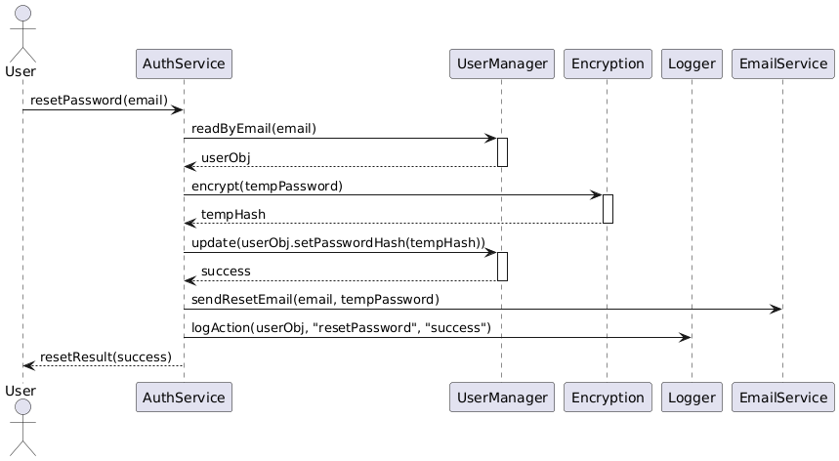

Actors & Components: User → AuthService → UserManager → Encryption → UserManager → EmailService → Logger
Explanation:
When a user requests a password reset, AuthService fetches the user via UserManager, generates a temporary password which is encrypted, updates the user record, and triggers EmailService to send the reset link. Logger tracks the reset event.

4. Sequence Diagram: Admin Updates Role
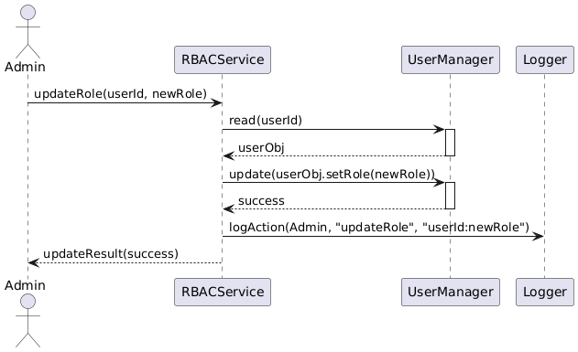
Actors & Components: Admin → RBACService → UserManager → Logger
Explanation:
An Admin explicitly calls RBACService.updateRole(userId, newRole). RBACService retrieves the target User via UserManager, updates their role attribute, persists the change, and Logger records the administrative action. This enforces RBAC and demonstrates the new updateRole() method.

5. Sequence Diagram: Disable Account
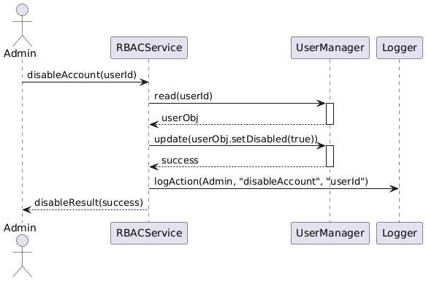
Actors & Components: Admin → RBACService → UserManager → Logger
Explanation:
To disable a user, Admin invokes RBACService.disableAccount(userId). The service marks the user as disabled in the UserManager and logs the action, preventing future authentications for that account.

6. Sequence Diagram: Add Book
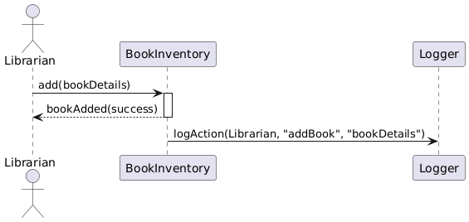
Actors & Components: Librarian → BookInventory → Logger
Explanation:
A Librarian adds a new book via BookInventory.add(). The inventory persists the book record and Logger logs “addBook” for audit. This uses the Manageable interface.

7. Sequence Diagram: Edit Book Record
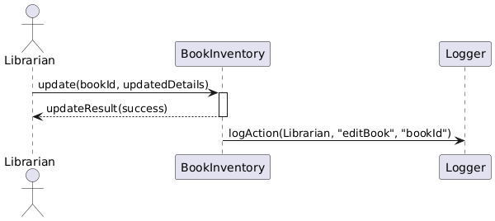
Actors & Components: Librarian → BookInventory → Logger
Explanation:
A book update is performed by calling BookInventory.update(book). On success, Logger records “editBook.

8. Sequence Diagram: Delete Book Record
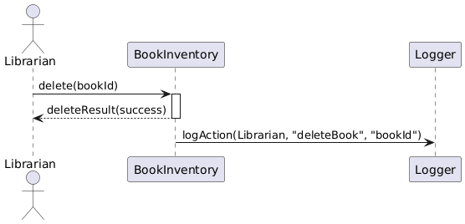
Actors & Components: Librarian → BookInventory → Logger
Explanation:
To remove a book, Librarian calls BookInventory.delete(bookId). The inventory deletes the record, and Logger logs “deleteBook.”

9. Sequence Diagram: Search for a Book
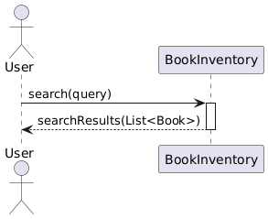
Actors & Components: User → BookInventory
Explanation:
Any user (Admin, Librarian, or Student) invokes BookInventory.search(query), which returns matching Book objects, demonstrating the Manageable interface’s read/search capability.

10. Sequence Diagram: Borrow Book
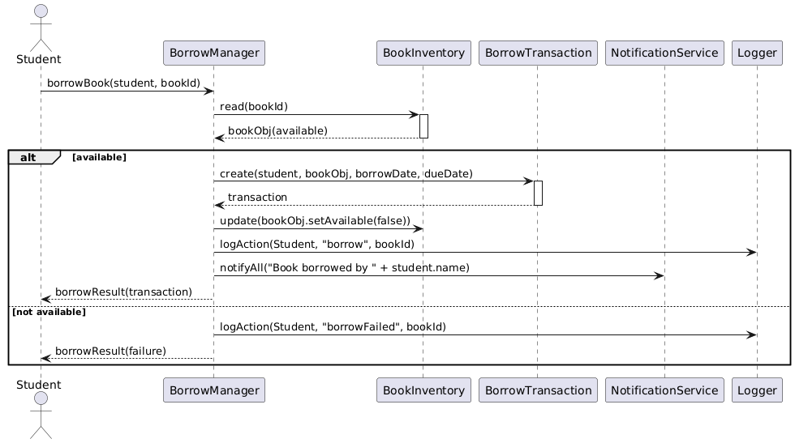
Actors & Components: Student → BorrowManager → BookInventory → BorrowTransaction → BookInventory → Logger → NotificationService
Explanation:
A Student requests BorrowManager.borrowBook(). The manager checks availability with BookInventory.read(), creates a BorrowTransaction, updates book availability, logs the borrow event, and uses NotificationService.notifyAll() to send confirmation.

11. Sequence Diagram: Return Book (with Fine Calculation)
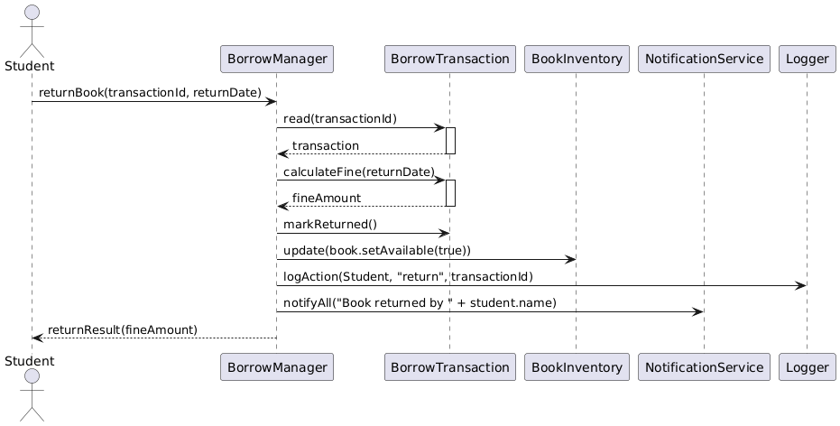
Actors & Components: Student → BorrowManager → BorrowTransaction → BorrowTransaction → BookInventory → Logger → NotificationService
Explanation:
For returning, Student calls BorrowManager.returnBook(). The manager retrieves and updates the BorrowTransaction, calculates any overdue fine, marks the book available again, logs the return, and notifies the student.

12. Sequence Diagram: Reserve Book
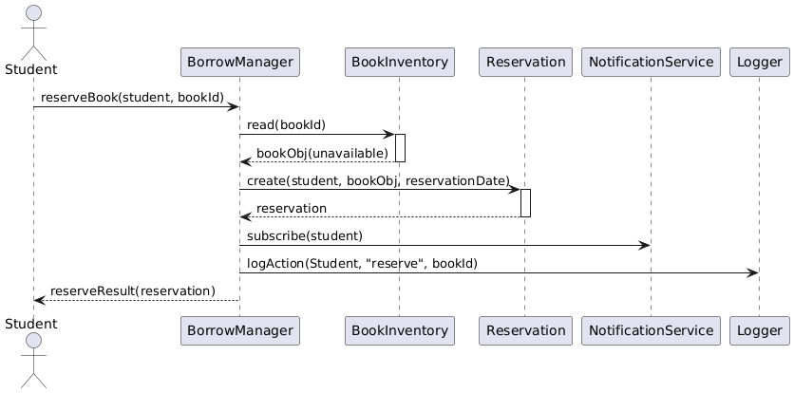
Actors & Components: Student → BorrowManager → BookInventory → Reservation → NotificationService → Logger
Explanation:
A Student uses BorrowManager.reserveBook(). If the book is unavailable, a Reservation is created, the student is subscribed to NotificationService, and the action is logged. Future availability triggers notifications.

13. Sequence Diagram: Due-Date Reminder Notification
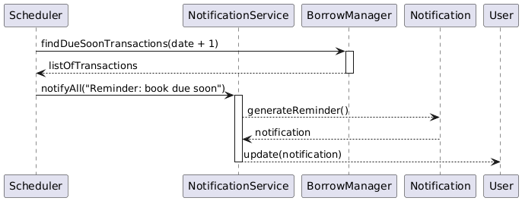
Actors & Components: Scheduler → BorrowManager → NotificationService → Notification → User
Explanation:
A scheduled task queries BorrowManager for soon-due records, then calls NotificationService.notifyAll("Reminder…"). Each Notification is generated and sent to all subscribed User observers.

14. Sequence Diagram: Overdue Notification
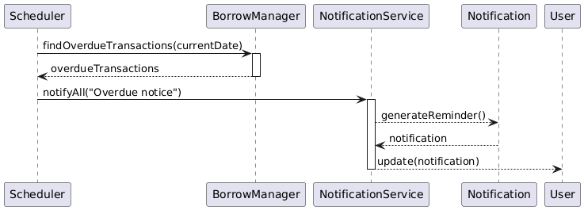
Actors & Components: Scheduler → BorrowManager → NotificationService → Notification → User
Explanation:
Similar to reminders, but the scheduler selects overdue records. NotificationService broadcasts an “Overdue” alert to affected users.

15. Sequence Diagram: Admin System Alert
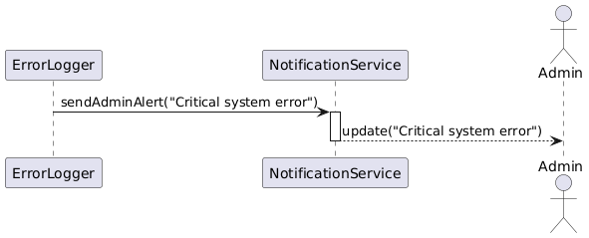
Actors & Components: ErrorLogger → NotificationService → Admin
Explanation:
On critical errors, ErrorLogger.logError() invokes NotificationService.sendAdminAlert(), which pushes an urgent message to all Admin observers.

16. Sequence Diagram: Error Handling
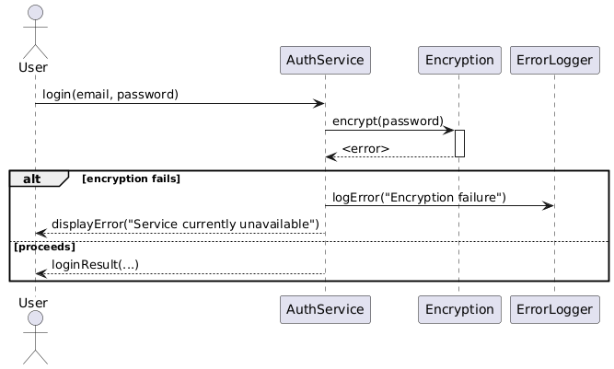
Actors & Components: User → AuthService → Encryption → ErrorLogger → User
Explanation:
If Encryption fails during login, AuthService catches the exception, logs it via ErrorLogger, and returns a user-friendly error screen. This illustrates robust error handling and secure communication.

